1. 1. Question

You are the administrator of your organization. The marketing team has requested the ability to create a survey and send it to external respondents. Which Office 365 application is best suited to perform this task?

* +  To Do
  +  Forms
  +  Planner
  +  Surveys

Unattempted

1. 2. Question

You want to limit the number of devices that can be enrolled by each user to two devices each. Within Microsoft Intune what functionality would you configure to implement this?

* +  Device Enrollment Manager
  +  Device Enrollment
  +  Device Enrollment Restrictions

Unattempted

1. 3. Question

The available groups that you can use within Office 365, include; Security Groups, Shared Mailbox Groups, _____ and _____.

* +  Global Groups
  +  Mail Enabled Security Groups
  +  Mail Distributed Groups
  +  Distributed Groups

Unattempted

In the Groups section of the Microsoft 365 admin center, you can create and manage these types of groups:  
Microsoft 365 groups (formerly Office 365 groups) are used for collaboration between users, both inside and outside your company.  
Distribution groups are used for sending notifications to a group of people.  
Security groups are used for granting access to resources such as SharePoint sites.  
Mail-enabled security groups are used for granting access to resources such as SharePoint and emailing notifications to those users.  
Shared mailboxes are used when multiple people need access to the same mailbox, such as a piece of company information or support email address.

1. 4. Question

What do you need to implement/configure to allow Microsoft Intune to manage Apple devices?

* +  Obtain a Push Notification (APN) certificate
  +  Configure MDM Authority
  +  Set-up a Google Play account

Unattempted

1. 5. Question

When assigning a policy you can either include or exclude groups

* +  TRUE
  +  FALSE

Unattempted

1. 6. Question

MAM requires Intune device enrollment.

* +  FALSE
  +  TRUE

Unattempted

1. 7. Question

You have already deployed Office 365 within your organization. You now need to deploy Microsoft Intune. Which of these set-up steps will you still need to complete?

* +  Add a custom domain
  +  Manage DNS settings
  +  Configure policies and profiles
  +  Configure Location

Unattempted

1. 8. Question

With the Cloud Identity model the user accounts are stored in Microsoft Azure___________

* +  Active Directory
  +  Account Manager
  +  Service Directory
  +  User Directory

Unattempted

1. 9. Question

In order to use the extensive reporting features of Desktop Analytics, you will need to create resources in the Azure admin center.

* +  FALSE
  +  TRUE

Unattempted

1. 10. Question

Users can connect their Microsoft mobile applications to their organization’s process by doing what?

* +  Installing a certificate on their device
  +  Configuring Azure Active Directory Identity Protection
  +  Configuring their Apple ID or Google ID to match their Office 365 Identity
  +  Signing in to the productivity applications using their Office 365 identity

Unattempted

1. 11. Question

When you remove an Office 365 license from a user for how long is the associated user’s data retained, by default?

* +  60 days
  +  1 day
  +  30 days
  +  90 days

Unattempted

1. 12. Question

Within Intune which policy types have precedence?

* +  Device Compliance Policies
  +  App Configuration Policies
  +  Device Configuration Profiles
  +  Device Configuration Policies

Unattempted

1. 13. Question

The User Administrator can

* +  manage user accounts, user groups, reset passwords, monitor the health of the service and assign admin roles
  +  manage user accounts, user groups, reset passwords, monitor the health of the service and create service requests
  +  manage user accounts, reset passwords, monitor the health of the service, create service requests and delete Global Administrators

Unattempted

1. 14. Question

An employee is leaving your company. They have used their own device to access corporate data. You need to ensure that all corporate data is wiped from the enrolled device. What Microsoft Intune remote action would you use?

* +  Remote Lock
  +  Full Wipe
  +  Passcode Reset
  +  Retire

Unattempted

1. 15. Question

You can manage groups within Office 365 by using the Microsoft 365 admin center and_______________.

* +  PowerShell
  +  Java
  +  C++
  +  ShellScript

Unattempted

1. 16. Question

Which of the following is the best description for a Federated Identity model?

* +  none of these
  +  User accounts based on-premises, synced to the cloud, verified by cloud
  +  User accounts based on-premises, synced to the cloud, verified by on-premises
  +  User accounts based on-cloud, synced to the cloud, verified by cloud

Unattempted

1. 17. Question

Your company has 200 remote users who have laptops that run Windows 10. The users store files in Microsoft OneDrive for Business.

You are configuring new laptops that will be deployed to the users. The new laptops have a smaller hard disk than the current laptops.

You need to minimize the amount of disk space used by OneDrive on the new laptops.

Which Group Policy setting should you configure?

* +  Prevent users from synchronizing personal OneDrive accounts
  +  Set the maximum percentage of upload bandwidth that OneDrive uses
  +  Enable OneDrive Files On-Demand
  +  Set the default location for the OneDrive folder

Unattempted

OneDrive Files On-Demandaccess all your files without using up your device storage  
<https://www.microsoft.com/en-us/microsoft-365/blog/2017/05/11/introducing-onedrive-files-on-demand-and-additional-features-making-it-easier-to-access-and-share-files/>

1. 18. Question

Mobile Device Management provides functionality to manage devices using profiles. What can you manage using Microsoft Intune device profiles?

* +  Device configuration and to configure access to resources
  +  Device compliance and access to resources
  +  Device compliance and to configure access to resources

Unattempted

1. 19. Question

You need to create a  profile for every ______________ you wish to manage when configuring MDM.

* +  Laptop
  +  Platform
  +  Brand
  +  Application

Unattempted

1. 20. Question

You host a live event. After the live event, users who were unable to attend want to view the recording. Which Office 365 application is suited to accomplish this task?

* +  Azure Active Directory
  +  Forms
  +  Planner
  +  Stream

Unattempted

1. 21. Question

You can view the past _____ days of Health History in the Microsoft 365 admin center.

* +  90
  +  30
  +  60
  +  21

Unattempted

1. 22. Question

You are working as an Office 365 Administrator. You want to ensure that you have the latest health information for Office 365. What app can you use to receive notifications to your smartphone?

* +  The Microsoft 365 Health app
  +  The Microsoft 365 Admin Mobile app
  +  The Office 365 Health app
  +  The Office 365 Support app

Unattempted

1. 23. Question

The default setting for the number of days in which a password expires is _____ days.

* +  60
  +  30
  +  120
  +  90

Unattempted

1. 24. Question

What is the name of the tool that allows you to sync user identity data between Active Directory and Azure Active Directory?

* +  Active Directory Domain Services
  +  Azure services
  +  Azure AD connect
  +  Azure AD Premium

Unattempted

1. 25. Question

Other than the Global Administrator which another administrator role has the permission to purchase licenses?

* +  Password Administrator
  +  Billing Administrator
  +  User Administrator
  +  License Administrator

Unattempted

1. 26. Question

Within the Microsoft 365 admin center, what is the name of the feature that allows you to see information on feature updates and scheduled maintenance?

* +  Message Center
  +  Alerts
  +  Service Health

Unattempted

1. 27. Question

The MDM Authority has two settings that you can configure. What are these settings?

* +  Office 365 Standalone and Intune Co-management
  +  Intune Standalone and Intune Co-management
  +  Intune Standalone & System Centre Co-management
  +  Microsoft 365 Standalone and Azure Connect Co-management

Unattempted

1. 28. Question

You have a Microsoft 365 subscription.  
You need to add a user named Admin1 as an administrator of the Microsoft OneDrive for  
Business site of a user named User1.  
What should you do?

* +  Add Admin1 to the Site owners group
  +  From the SharePoint admin center, select user profiles, and then select Manage User Permissions.
  +  From the SharePoint admin center, select user profiles, and then select Manage User Profiles. Select User1, and then select Manage site collection owners.
  +  Run the Set-SPOSite (site URL) Owner Admin1 command.

Unattempted

1. 29. Question

You need to enable an internal social networking platform to allow users to communicate informally. Which Office 365 application is best suited to accomplish this?

* +  Stream
  +  Yammer
  +  Forms
  +  Planner

Unattempted

1. 30. Question

Before you start to enroll devices you need to set the MDM Authority.

* +  FALSE
  +  TRUE

Unattempted

1. 31. Question

Conditional Access policies use Controls to decide if access should be granted, What is the other element of Conditional Access policies?

* +  Conditions
  +  Configuration
  +  Controllers

Unattempted

1. 32. Question

Once you have created a new policy in Microsoft Intune how will you deploy the policy?

* +  Upload the policy to the Company Portal
  +  Assign the policy to individual users
  +  Assign the policy to the device, or user groups
  +  Save the policy within Intune

Unattempted

1. 33. Question

You need to enable your users to create and manage projects using the Office 365 suite. Which Office 365 application is best suited to accomplish this task?

* +  SharePoint Online
  +  Planner
  +  Microsoft Outlook
  +  Stream

Unattempted

A planner can be used to create simple projects or plans and allows for participating to assign and manage tasks. The planner can be integrated into teams.

1. 34. Question

When you sign-up for Office 365 the first user created is the Global Administrator

* +  FALSE
  +  TRUE

Unattempted

1. 35. Question

What is the most common form of identity authentication?

* +  Hash
  +  Password
  +  token
  +  Fingerprint

Unattempted

1. 36. Question

You can use the Microsoft 365 admin center to request a support call from Microsoft to help with any Office 365 issues.

* +  FALSE
  +  TRUE

Unattempted

1. 37. Question

Within the Microsoft 365 admin center the View Service History page shows Health History for the last 7 and _____ days.

* +  30
  +  20
  +  90
  +  120

Unattempted

1. 38. Question

By default the Microsoft 365 admin center shows _____ days of Health History.

* +  7
  +  30
  +  1
  +  9

Unattempted

1. 39. Question

Within Microsoft Intune, you can manage devices and apps using ______ and _____.

* +  Profiles and Settings
  +  Profiles and Policies
  +  Configuration and Policies
  +  Rules and Policies

Unattempted

1. 40. Question

Microsoft Enterprise Mobility+ Security features rely on ___________ -driven security.

* +  Identity
  +  Software
  +  Application
  +  Platform

Unattempted

1. 41. Question

A new setting was introduced with Windows 10 1803 that allows you to set policy precedence between Intune policies and Group Policy. What is the name of the setting?

* +  ControlPolicyConflict
  +  PolicyConflictControl
  +  ManagePolicyConflict

Unattempted

1. 42. Question

Risk-based Conditional Access is a feature of

* +  AAD Premium P1
  +  AD
  +  Privileged Identity Management
  +  AAD Premium P2

Unattempted

Most users have a normal behavior that can be tracked, when they fall outside of this norm it could be risky to allow them to just sign in. You may want to block that user or maybe just ask them to perform multi-factor authentication to prove that they are really who they say they are.  
A sign-in risk represents the probability that a given authentication request isn’t authorized by the identity owner. Organizations with Azure AD Premium P2 licenses can create Conditional Access policies incorporating Azure AD Identity Protection sign-in risk detections.  
More Information:  
<https://docs.microsoft.com/en-us/azure/active-directory/conditional-access/howto-conditional-access-policy-risk>

1. 43. Question

Microsoft Defender Advanced Threat Protection can protect Mac OS-based computers

* +  TRUE
  +  FALSE

Unattempted

The answer is True as Microsoft ATP can; protect Mac OS based computers. For information on how to install Microsoft ATP please read the following Microsoft link  
<https://docs.microsoft.com/en-us/windows/security/threat-protection/microsoft-defender-atp/mac-install-manually>

1. 44. Question

Which of the following is NOT a feature of Desktop Analytics?

* +  Device and software inventory
  +  App compatibility
  +  Azure Log Analytics
  +  Windows Analytics

Unattempted

Desktop Analytics is a cloud-based service that integrates with Configuration Manager. The service provides insight and intelligence for you to make more informed decisions about the update readiness of your Windows clients.  
Use Desktop Analytics with Configuration Manager to:  
Create an inventory of apps running in your organization  
Assess app compatibility with the latest Windows 10 feature updates  
Identify compatibility issues, and receive mitigation suggestions based on cloud-enabled data insights  
Create pilot groups that represent the entire application and driver estate across a minimal set of devices  
Deploy Windows 10 to pilot and production-managed devices

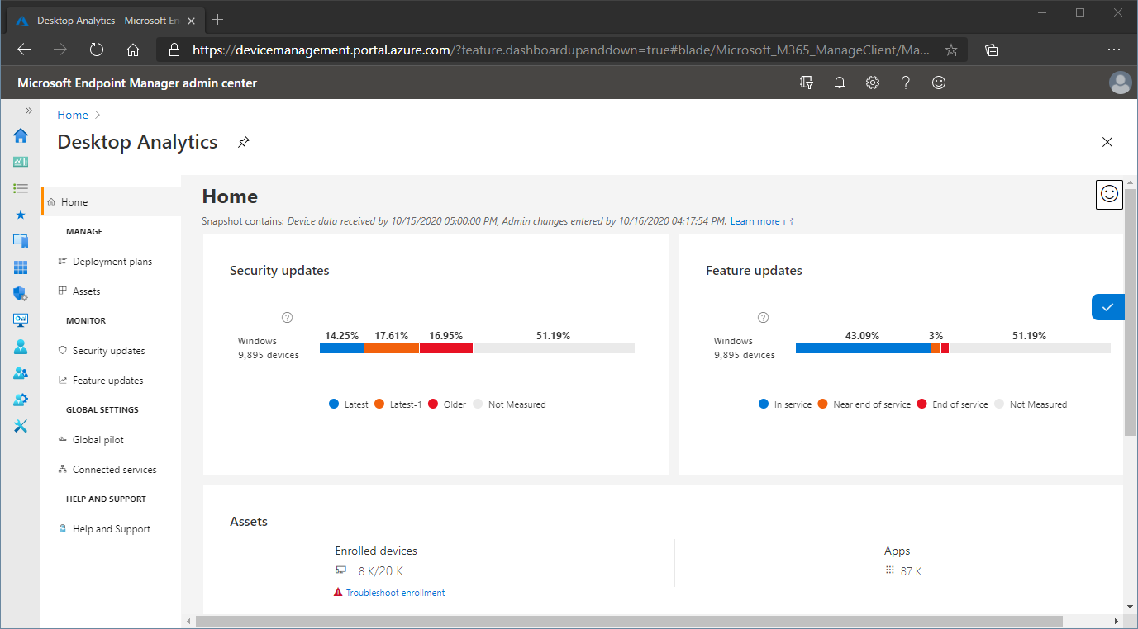

1. 45. Question

Microsoft 365 Usage Analytics can be imported into which two tools or services?

* +  Power BI Network
  +  Power BI Enterprise
  +  Power BI Desktop
  +  Power BI

Unattempted

Use Microsoft 365 usage analytics within Power BI to gain insights on how your organization is adopting the various services within Microsoft 365 to communicate and collaborate. It is accessible both through Power BI as well as through Power BI Desktop.  
More Info:  
<https://docs.microsoft.com/en-us/microsoft-365/admin/usage-analytics/usage-analytics?view=o365-worldwide>

1. 46. Question

eDiscovery managers can see

* +  Only cases that they created or are assigned to them
  +  All cases

Unattempted

eDiscovery Managers can only access and manage the cases they create. They can’t access or manage cases created by other eDiscovery Managers.  
<https://docs.microsoft.com/en-us/microsoft-365/compliance/assign-ediscovery-permissions?view=o365-worldwide>

1. 47. Question

Vini is a compliance administrator for ABC company and she has been asked to perform a search for users who have accessed certain SharePoint sites. Which tool should Vini use?

* +  SharePoint admin center
  +  SharePoint Report Server
  +  Audit log search
  +  Microsoft 365 admin center

Unattempted

Search the audit log in the Security & Compliance Center for users who have accessed certain SharePoint sites.  
For a detailed understanding of the capabilities of Audit Log Search the following link would be useful  
<https://docs.microsoft.com/en-us/microsoft-365/compliance/search-the-audit-log-in-security-and-compliance?view=o365-worldwide>

1. 48. Question

In order to reduce exposure for personally identifiable information, administrators can enable what feature for Microsoft 365 Activity Reports?

* +  Anonymization
  +  Randomization
  +  Obfuscation
  +  Exfiltration

Unattempted

User-level details can be deliberately hidden in the Office 365 Admin Center when generating reports through a feature called Anonymization. We can use this feature when generating reports like OneDrive or usage reports without showing names and email addresses. In this way, user identities are protected.

1. 49. Question

What is Office Online?

* +  the free-to-anyone online versions of Office apps
  +  Microsoft's website dedicated to all Office topics

Unattempted

Microsofts Office Online is a completely free, web-based version of Microsoft Office. This online office suite is clearly competing with Google Docs, but its also a potential replacement for the desktop version of Office.  
More Info:  
<https://www.howtogeek.com/183299/a-free-microsoft-office-is-office-online-worth-using/>

1. 50. Question

Which three verification methods of the following choices are official choices for Azure MFA?

* +  Phone call
  +  One-time passcode
  +  Desktop Popup
  +  SMS or Text Message

Unattempted

When a user signs in to an application or service and receives an MFA prompt, they can choose from one of their registered forms of additional verification. An administrator could require registration of these Azure Multi-Factor Authentication verification methods, or the user can access their own My Profile to edit or add verification methods.  
The following additional forms of verification can be used with Azure Multi-Factor Authentication:  
Microsoft Authenticator app  
OATH Hardware token  
SMS  
Voice call

Read the following article for additional information  
<https://docs.microsoft.com/en-us/azure/active-directory/authentication/concept-mfa-howitworks>

1. 51. Question

What does Microsoft Cloud App Security use to protect apps and app data?

* +  Profiles
  +  Policies
  +  Alerts

Unattempted

You can create app discovery policies to alert you when new apps are detected. Cloud App Security also searches all the logs in your Cloud Discovery for anomalies.  
<https://docs.microsoft.com/en-us/cloud-app-security/cloud-discovery-policies>

1. 52. Question

Users can be managed using groups. What else can be managed using groups?

* +  products
  +  Services
  +  devices
  +  Administrators

Unattempted

Intune uses the Azure Active Directory (Azure AD) groups to manage devices and users. As an Intune admin, you can set up groups to suit your organizational needs. Create groups to organize users or devices by geographic location, department, or hardware characteristics. Use groups to manage tasks at scale. For example, you can set policies for many users or deploy apps to a set of devices.  
You can add the following types of groups:  
Assigned groups – Manually add users or devices into a static group.  
Dynamic groups (Requires Azure AD Premium) – Automatically add users or devices to user groups or device groups based on an expression you create.  
For example, when a user is added with the manager title, the user is automatically added to an All manager’s user group. Or, when a device has the iOS/iPadOS device OS type, the device is automatically added to an All iOS/iPadOS devices group.

1. 53. Question

When using the Active Hours feature, within Windows Update, what is the maximum length of time that can be set as ‘active hours’?

* +  12 hrs
  +  14 hrs
  +  16 hrs
  +  18 hrs

Unattempted

You can stop Windows 10 from restarting your PC automatically to apply updates while you’re actively using it.  
Although there’s not an option in the Settings app to disable updates entirely, Windows 10 ships with “active hours,” which is a feature meant to make updates less intrusive by letting you specify the time you’ll be working on your computer. This means that if an update is pending, the reboot will occur outside the active hours.  
The maximum amount of time you can set is 18 hours. If you specify a range that’s more than that, it’ll be marked as invalid

1. 54. Question

Microsoft Secure score actions are grouped into which four categories

* +  Apps
  +  MFA
  +  Identity
  +  Windows
  +  Azure
  +  Data

Unattempted

Microsoft Secure Score is a measurement of an organization’s security posture, with a higher number indicating more improvement actions taken.  
Microsoft Secure Score improvement actions are organized into groups:  
Identity (Azure Active Directory accounts & roles)  
Data (Microsoft Information Protection)  
Device (Microsoft Defender ATP, known as Microsoft Secure Score for Devices)  
App (email and cloud apps, including Office 365 and Microsoft Cloud App Security)  
Infrastructure (no improvement actions for now)

More info:  
<https://docs.microsoft.com/en-us/microsoft-365/security/mtp/microsoft-secure-score-improvement-actions?view=o365-worldwide>

1. 55. Question

If you want users to review their own personal work habit analytics. Which service should you direct them to?

* +  Microsoft 365 Activity Reports
  +  Power BI
  +  Microsoft 365 Usage Analytics
  +  My Analytics

Unattempted

Microsoft MyAnalytics is an application designed to help employees and their managers gain insight into how workers spend their time, with the goal of optimizing tasks and making them more efficient.

1. 56. Question

Rose is a SharePoint administrator for ABC company. Rose has been asked to allow OneDrive users to share documents with external users who have already been added to ABC company’s AAD tenant. Which option should Rose choose?

* +  Only people in ABC company
  +  Anyone
  +  New & existing external users
  +  Existing external users

Unattempted

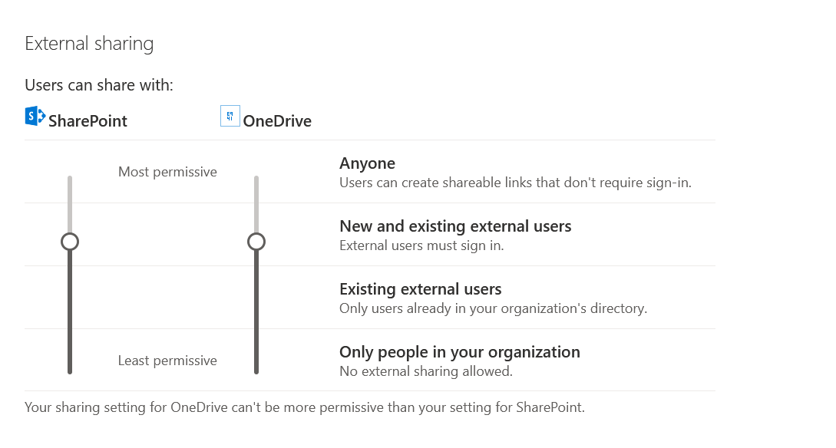

1. 57. Question

Identify four areas that My Analytics reports on

* +  Security
  +  Network
  +  Collaboration
  +  Focus
  +  Teamwork
  +  Wellbeing

Unattempted

1. 58. Question

To fully manage a device using a Mobile Device Management service, what initial action needs to be completed?

* +  Register the device with Windows AutoPilot.
  +  Enroll the device into the MDM service.
  +  Set-up profile and device permissions.
  +  Assign a license to the device.

Unattempted

You can manage different aspects of devices using the features built into Intune. This approach is called Mobile device management (MDM). Users “enroll” their devices, and use certificates to communicate with Intune. As an IT administrator, you push apps on devices, restrict devices to a specific operating system, block personal devices, and more. If a device is ever lost or stolen, you can also remove all data from the device.  
More Info:  
<https://docs.microsoft.com/en-us/mem/intune/fundamentals/what-is-device-management>

1. 59. Question

Conditional Access is a feature of

* +  AAD Premium 1
  +  AD
  +  Cloud App security
  +  Privileged Identity Management

Unattempted

<https://azure.microsoft.com/en-us/pricing/details/active-directory/>

1. 60. Question

SharePoint Online document lifecycle has three terms related to it. Can you identify those terms

* +  Azure Ad recycle bin
  +  Versioning
  +  Two-stage recycle bin
  +  Preservation Hold Library

Unattempted

Versioning is the method by which successive iterations of a document are numbered and saved in SharePoint.  
To support retention, SharePoint and OneDrive create a Preservation Hold library if one doesn’t exist. You can view this library on the Site contents page in the top-level site of the site collection. Most users can’t view the Preservation Hold library because it’s visible only to site collection administrators.  
The Site Collection (Second-Stage) Recycle Bin gives the administrator of a site collection greater control over deleted items by providing a second-stage safety net before an item is permanently deleted from a site. When you delete an item from your Recycle Bin, the item is sent to a second stage Recycle Bin (also known as the Site Collection (Second-Stage) Recycle Bin) that the administrator of the site collection manages.